User Manual

FMS^{NG} Application

Shell Energy Marketing and Trading India Private Limited
Project Sponsoring Business

Master Module

07 MARCH 2024
Date

Table of Contents
1. Master Module Overview 3
1.1. User Interface / Screen Designs 3
2. Menu Network / Screen Navigation 5
2.1. Sub Module – Counterparty 5
2.2. Sub Module – Tax 20
2.3 Sub Module – Other 23
3 Report Design and Layout 28
3.1 Sub Module – Reports 28
4 Auditing 30

Master Module Overview
FMS^{NG} Application is an efficient ETRM System for Domestic Gas Trading, customized to meet business requirement of Shell Energy Marketing and Trading India Private Limited (SEMTIPL).
FMS^{NG} Master Module will create and manage all critical master elements of the trading system as listed below:
- Counterparty Creation and Management
- Entity Role Creation and Management
- Entity Contact Creation and Management
- Tax Master and Tax Structure Creation and Management
- Exchange/Interest Rate Management
- Meter Creation and Management
- Bank Master
- Holiday Master
- Energy Sector Master
- System will trigger event based emails as applicable
- Management and Audit Reports
The Master Module is more relevant for System Operators.

User Interface / Screen Designs

FMS^{NG} offers Responsive UI to enable usability via any smart phone, tab and laptop of any screen size. The Menus of Admin module are as below:

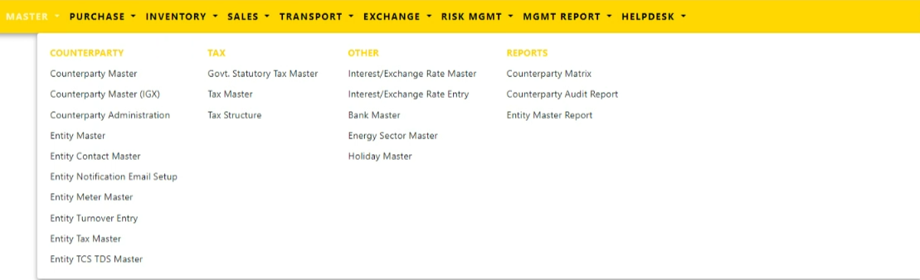

The responsive mode view over iPhone simulation:
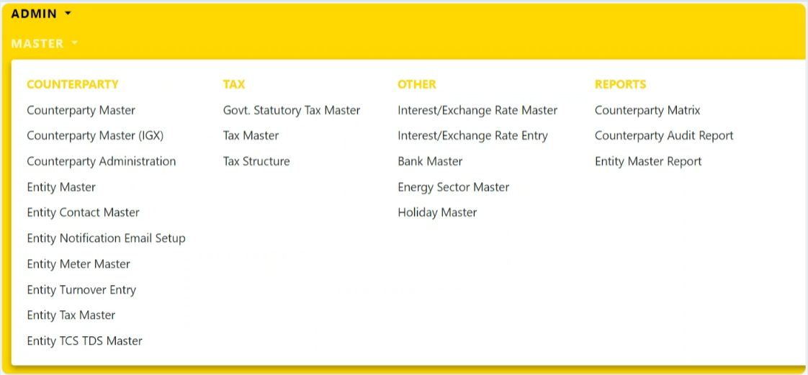

Menu Network / Screen Navigation
Menus in any Module are kept under different Groups for better categorization. The Groups under Master Module are Counterparty, Tax, Other and Reports.

Sub Module – Counterparty

‘Counterparty’ Group provides forms to manage various counterparties and entities within the application.

Counterparty Counterparty Master

Counterparties in FMS^{NG} Application added/modified from this FORM by User.

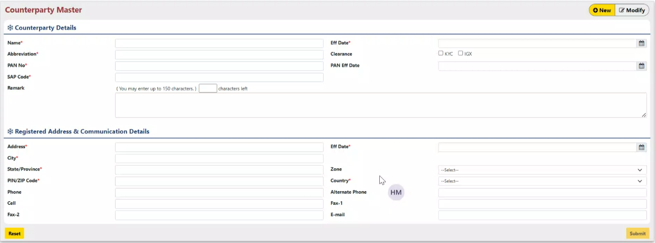

To add a new Counterparty, Fill in the required information:
- Name: Enter the full name of the counterparty.
- Eff Date: Specify the date the counterparty information becomes effective.
- Abbreviation: Provide a short and recognizable abbreviation for the counterparty.
- Clearance: Select whether the counterparty is KYC verified.
- PAN No: Enter the counterparty's Permanent Account Number (PAN).
- PAN Eff Date: Specify the effective date of the counterparty's PAN.
- SAP Code: Enter the counterparty's unique SAP code.
- Remarks: Include any additional information or notes about the counterparty.

Registered Address:

- Address: Enter the counterparty's full registered address.
- Effective Date: Specify the date the registered address becomes effective.
- City: Enter the city where the counterparty is registered.
- State: Enter the state or province where the counterparty is registered.
- Zone: Enter the zone or district (optional) of the registered address.
- Pin/Zip Code: Enter the postal code of the registered address.
- Country: Select the country where the counterparty is registered.

Communication Details:

- Phone: Enter the counterparty's primary phone number.
- Cell: Enter the counterparty's mobile phone number.
- Alternative Phone: Enter an alternative phone number (optional) for the counterparty.
- Fax-1: Enter the counterparty's primary fax number (optional).
- Fax-2: Enter the counterparty's secondary fax number (optional).
- Email: Enter the counterparty's primary email address

After inserting all the details, click on “Submit” Button. A dialogue box asking your permission to insert the Counterparty in system appears as shown below:

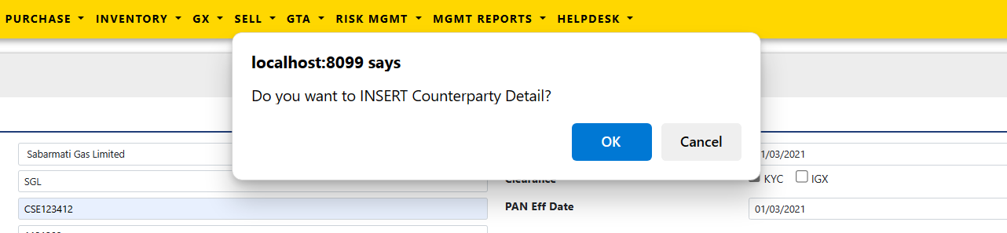

Press Ok. The status of counterparty insertion in system get displayed on the top of the screen.

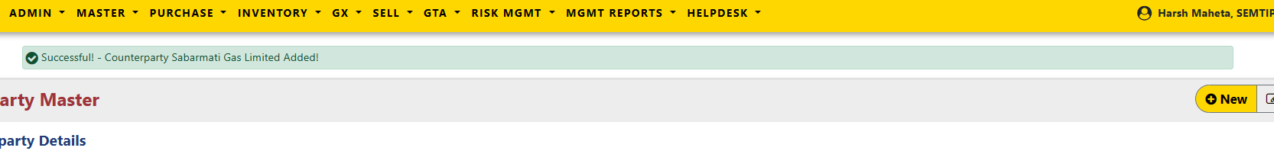

Counterparty Counterparty Master(IGX)

IGX Counterparties in FMS^{NG} Application added/modified from this FORM by User.

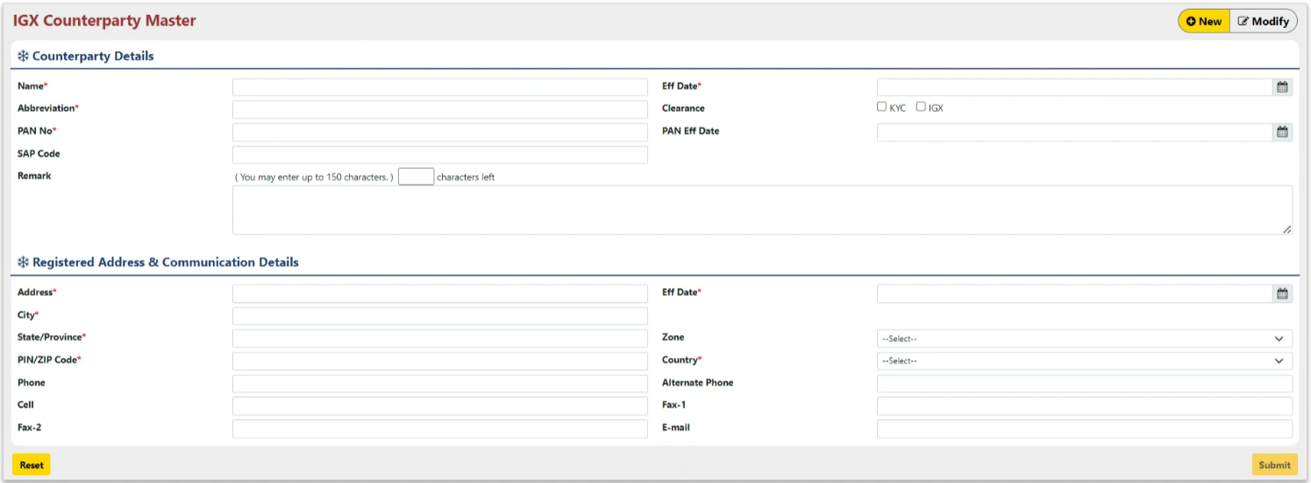

To add a new IGX Counterparty, Fill in the required information:
- Name: Enter the full name of the counterparty.
- Eff Date: Specify the date the counterparty information becomes effective.
- Abbreviation: Provide a short and recognizable abbreviation for the counterparty.
- Clearance: Select whether the counterparty is IGX certified.
- PAN No: Enter the counterparty's Permanent Account Number (PAN).
- PAN Eff Date: Specify the effective date of the counterparty's PAN.
- SAP Code: Enter the counterparty's unique SAP code.
- Remarks: Include any additional information or notes about the counterparty.

Registered Address:

- Address: Enter the counterparty's full registered address.
- Effective Date: Specify the date the registered address becomes effective.
- City: Enter the city where the counterparty is registered.
- State: Enter the state or province where the counterparty is registered.
- Zone: Enter the zone or district (optional) of the registered address.
- Pin/Zip Code: Enter the postal code of the registered address.
- Country: Select the country where the counterparty is registered.

Communication Details:

- Phone: Enter the counterparty's primary phone number.
- Cell: Enter the counterparty's mobile phone number.
- Alternative Phone: Enter an alternative phone number (optional) for the counterparty.
- Fax-1: Enter the counterparty's primary fax number (optional).
- Fax-2: Enter the counterparty's secondary fax number (optional).
- Email: Enter the counterparty's primary email address

After inserting all the details, click on “Submit” Button. A dialogue box asking your permission to insert the Counterparty in system appears as shown below:



Press Ok. The status of IGX Counterparty insertion in system get displayed on the top of the screen.



Counterparty Counterparty Administration

Counterparties entity roles are assigned for FMS^{NG} Application in this FORM by User.

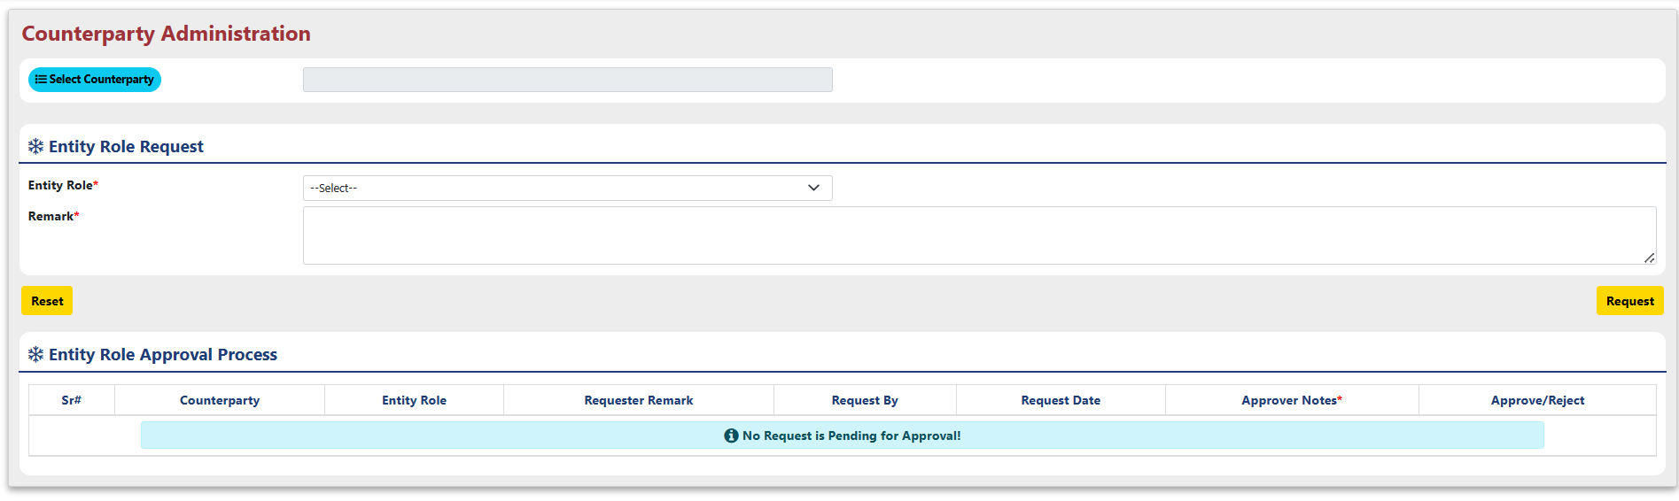
- Entity Role Request:
- Select a Counterparty: Click the "Select Counterparty" button.
- Choose from the List: A pop-up window will appear, displaying a list of available counterparties. Click on the desired counterparty to select it.

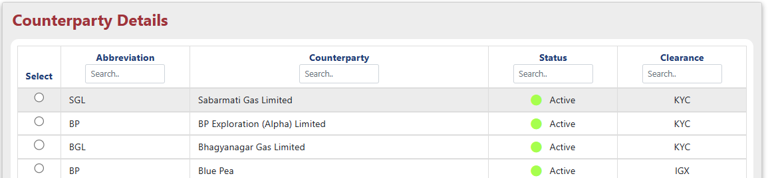

- A dropdown menu will appear below the selected counterparty. If applicable, select the entity's role from the list, which include options "Customer," "Trader," or "Transporter."
- After entering details, add any remarks and click Request.

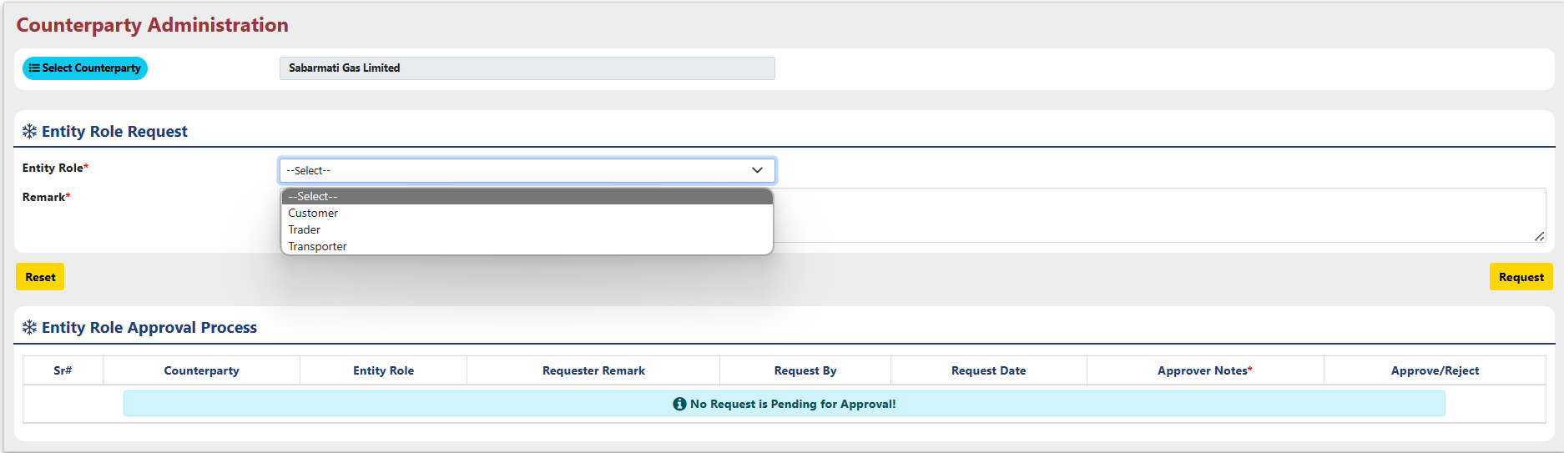

- Entity Role Approval Process:

- Click the button next to the SR number.

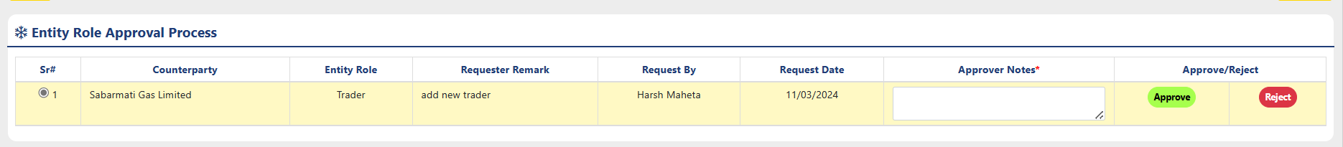

- If the functionality allows for approval/rejection, you may find an "Approval Notes" section. Here, you can enter any comments or justifications for your decision.
- After clicking "Approve" or "Reject," a pop-up message will likely appear to confirm your action. This message might display details like:

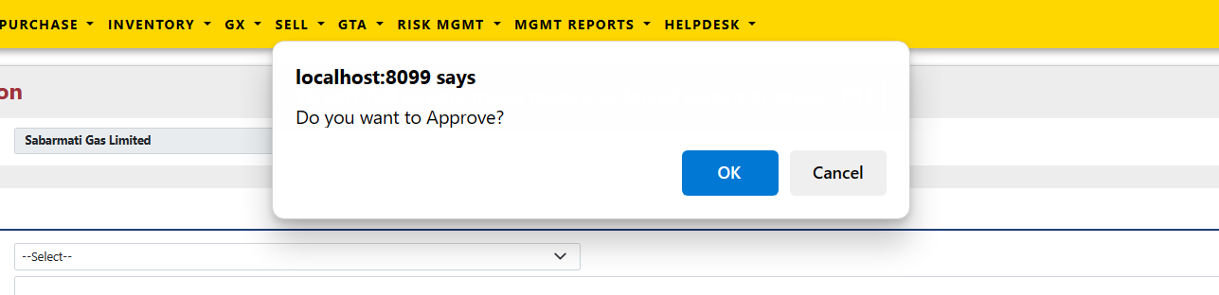

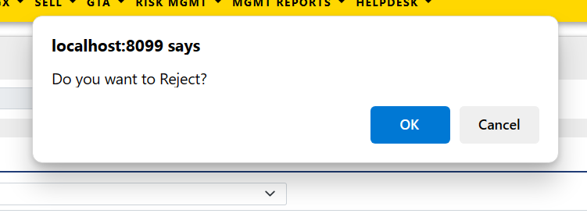

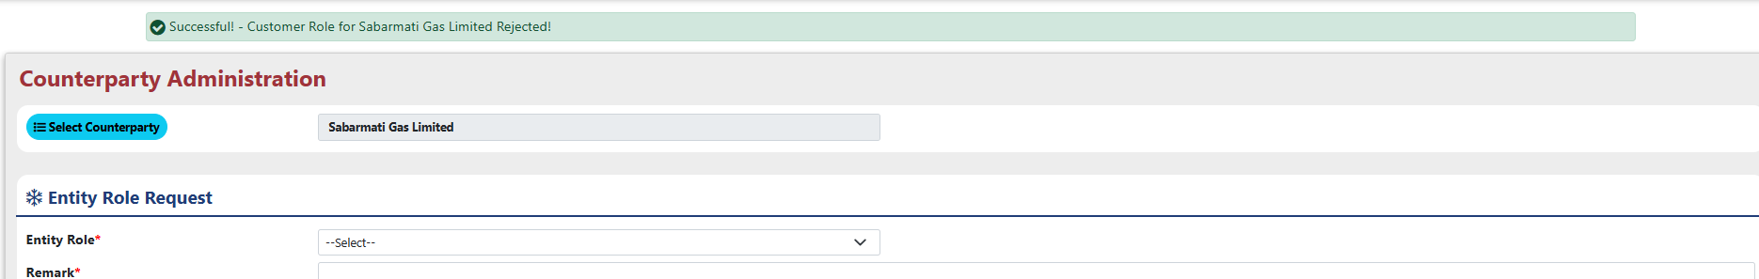
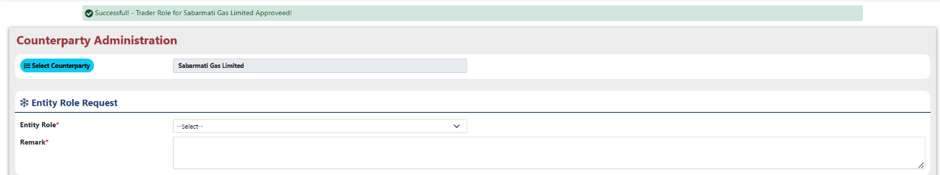
- Once you confirm your action by clicking the appropriate button in the pop-up window (typically "OK" or "Confirm"), you will receive a message as below.

Counterparty Entity Master

The Entity Master Form allows you to manage entities according to their associated roles, including maintaining their address information.

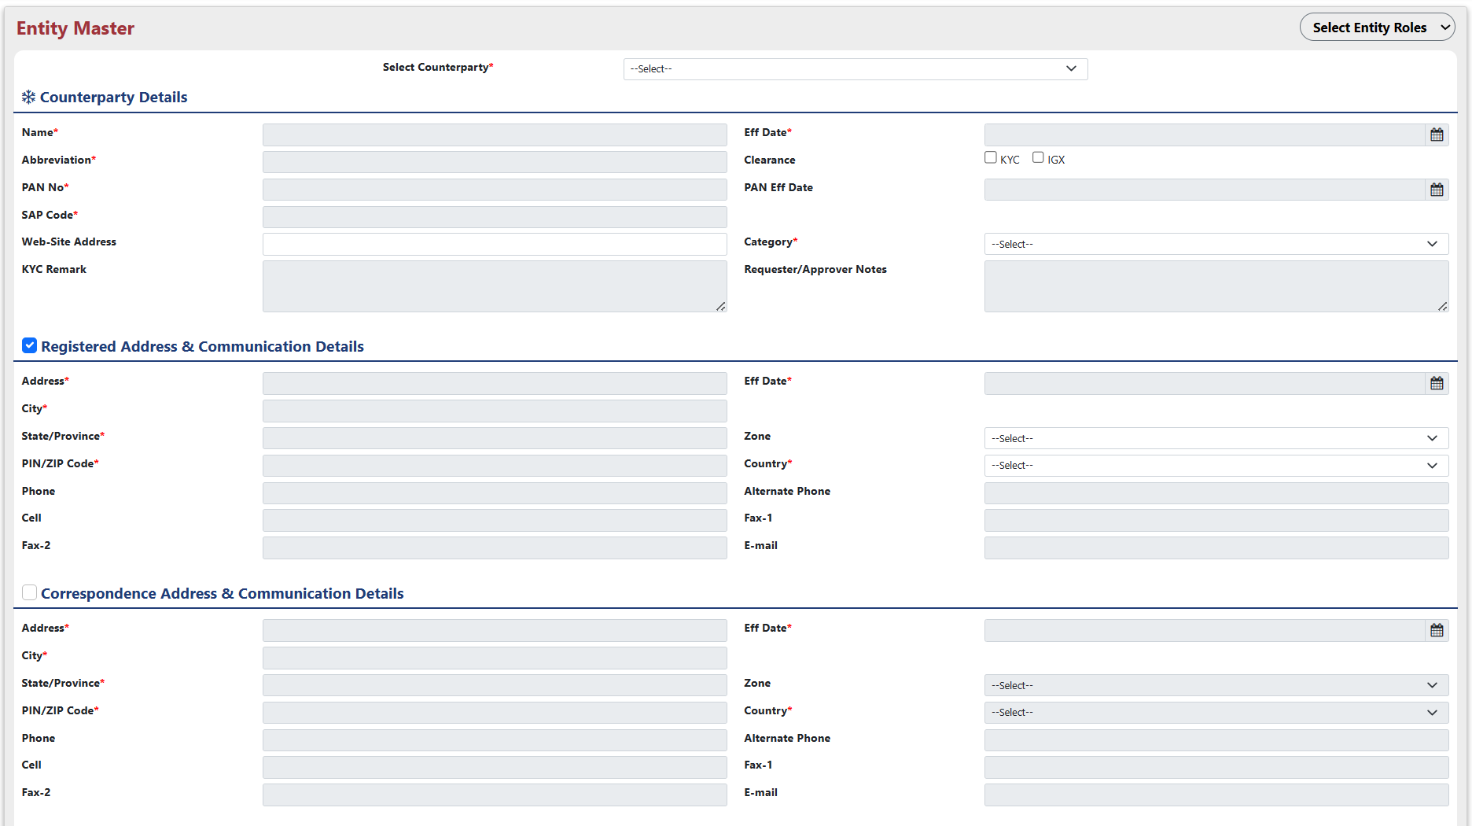

Choose an Entity Role from the dropdown menu.

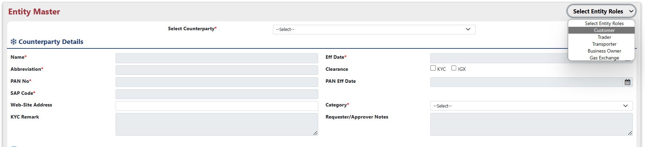
Choose an Entity from the dropdown menu.

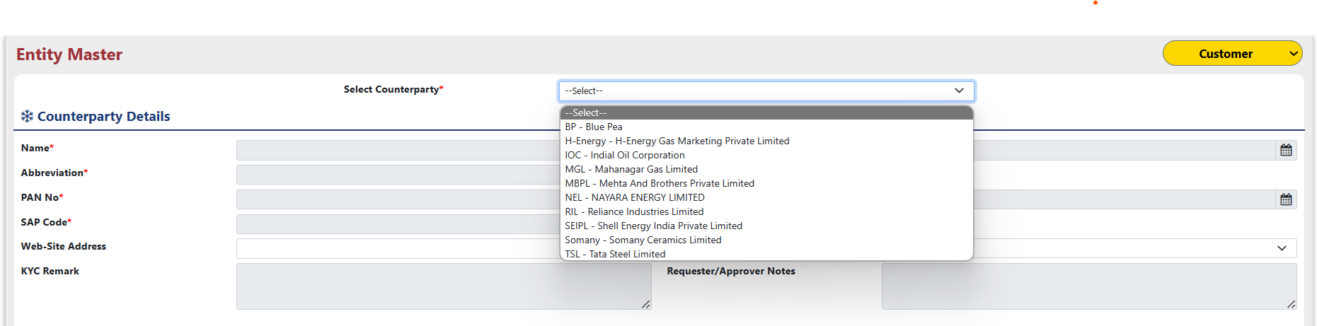

It will automatically fill the details for Counterparty, you can modify below fields:

- Web-Site Address: Enter the counterparty's primary Web-Site address.
- Category: Select the counter party category from the dropdown menu.

For entity role Business owner you can configure bank details by clicking on the button “Bank Details Config”.

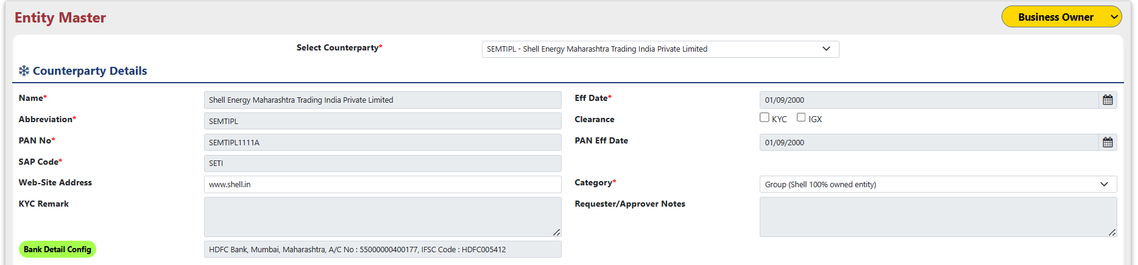

By clicking on that button it will open below popup.

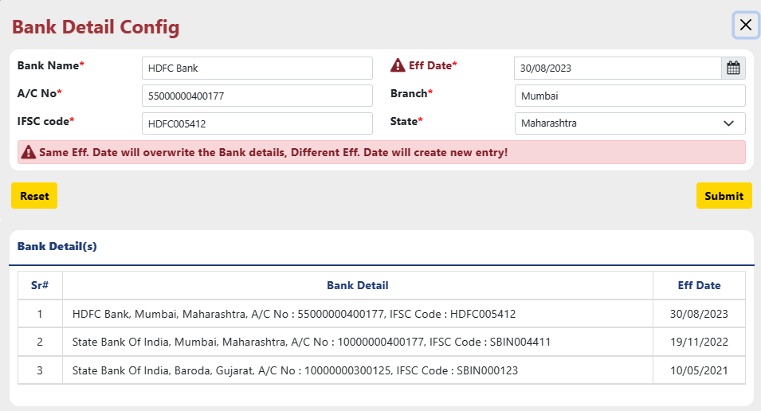

Bank Detail Config:

- Bank Name: Enter the full name of the bank where the business owner holds the account.
- A/C No.: Enter the complete account number associated with the business owner's bank account.
- IFSC Code: Provide the IFSC for the branch where the account is held.
- Effective Date: Specify the date from which the provided bank account information becomes valid for the business owner.
- Branch: Enter the name or code of the specific branch where the business owner's account is located.
- State: Select the state where the branch holding the business owner's account is located.

The 'Bank Details' table below displays all bank accounts associated with the business owner.

Select the checkbox corresponding to the desired address type (Registered Address, Correspondence, Billing, or Plant(s)/Office(s)) and fill in the following details.

- Address: Enter the counterparty's full registered address.
- Effective Date: Specify the date the registered address becomes effective.
- City: Enter the city where the counterparty is registered.
- State: Enter the state or province where the counterparty is registered.
- Zone: Enter the zone or district (optional) of the registered address.
- Pin/Zip Code: Enter the postal code of the registered address.
- Country: Select the country where the counterparty is registered.

Plant(s)/Office(s) Address & Communication Details:

- The 'Plant(s)/Office(s) Address & Communication Details' table displays information about all associated plants or offices.

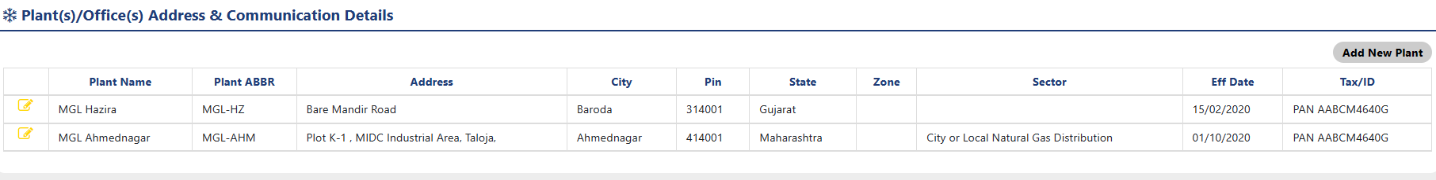

- Add a new plant by clicking the "Add New Plant" button. To modify existing plant details, click the "pen icon" next to the desired plant, which will open a pop-up window.
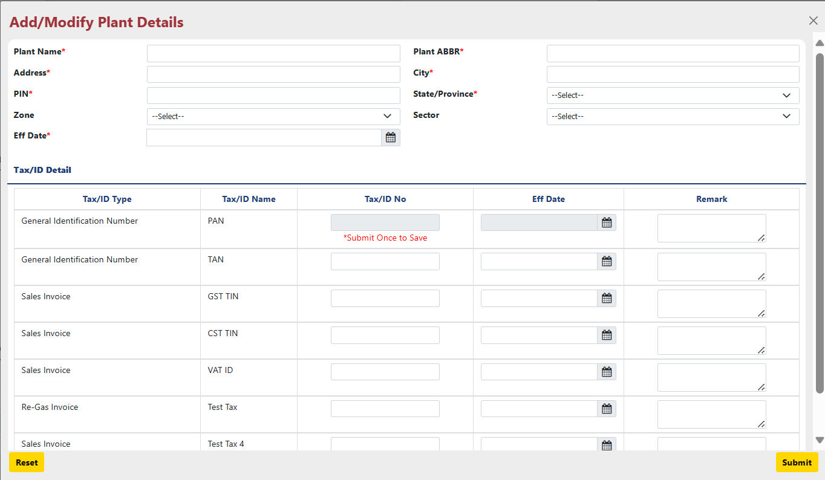

- Plant Name: Enter the official name of the plant.
- Plant ABBR: Create a short and unique abbreviation for the plant.
- Address: Provide the complete address of the plant.
- City: Enter the city where the plant is located.
- PIN: Provide the postal code (PIN) for the plant's location.
- State/Province: Select the state or province where the plant is located from the dropdown menu.
- Zone: Select the zone (North, South, East, West) where the plant is situated.
- Sector: Choose the sector the plant belongs to from the provided options.
- Effective Date: Specify the date from which the plant information becomes valid.
- Remark: Add any comments or notes relevant to the plant (e.g., specific details about its operation).
- Tax/ID Type: Select the type of tax identification.
- Tax/ID Name: Enter the name associated with the tax identification
- Tax/ID No.: Provide the actual tax identification number.
- Effective Date: Specify the date from which this tax information becomes valid for the plant.
- Remark: Add any additional comments or notes regarding the tax information.

Once you've filled in all the necessary details, click the "Submit" button at the bottom of the pop-up window to save your changes.

Counterparty Entity Contact Master

The Entity Contact Master Form allows you to manage entities contacts details according to their associated roles.
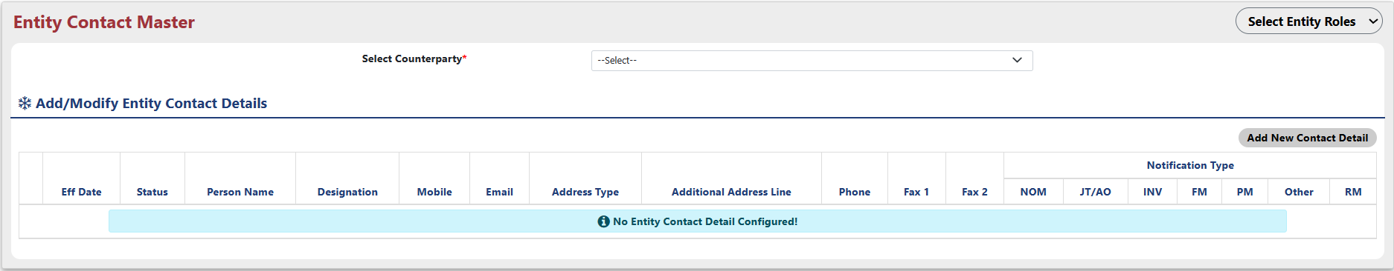

- Select the desired entity role from the first dropdown menu.
- Choose the specific counterparty from the second dropdown menu.
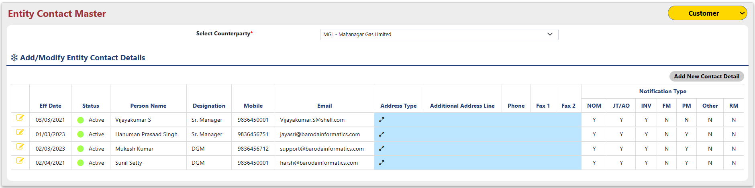

- The table below, titled "Add/Modify Entity Contact Details," will automatically display the contact information for the chosen counterparty based on the selected entity role.
- Click the "Add New Contact Detail" button to initiate adding a new contact person. This will open a modal where you can enter the contact's details.

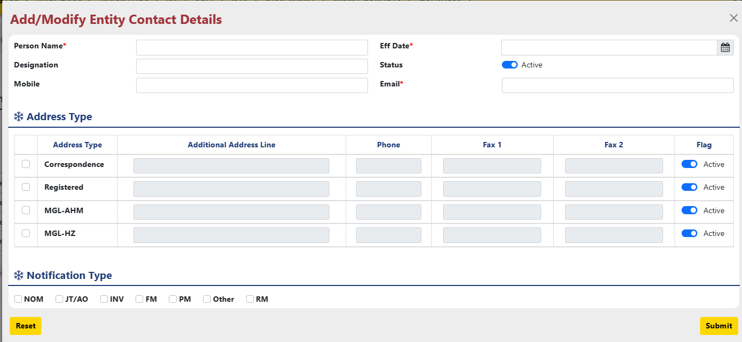
- Person Name: Enter the full name of the contact person.
- Designation: Specify the contact person's job title or designation within the counterparty organization.
- Status: This section likely displays the current status of the contact person (e.g., Active, Inactive).
- Mobile: Enter the contact person's mobile phone number, including the country code.
- Email: Provide the contact person's primary email address.

- "Address Type" serves to categorize the purpose of the contact person's address. Selecting the appropriate type ensures the address information is used for the intended communication or purpose.
  - Correspondence
  - Billing
  - Plant(s)/Office(s)

- Notification Type:
  - NOM : Nomination
  - JT/AP : Joint Ticket / Allocation
  - INV : Invoice
  - FM : Force Measure
  - PM : Plan Measure
  - RM : Remittance

- Click the "Submit" button to save the newly entered contact information. To edit an existing contact, click the "pen icon" next to their effective date.

Counterparty Entity Email Setup

The "Entity Email Setup" menu used to be a functionality within a system or application, related to managing email addresses for various entities.

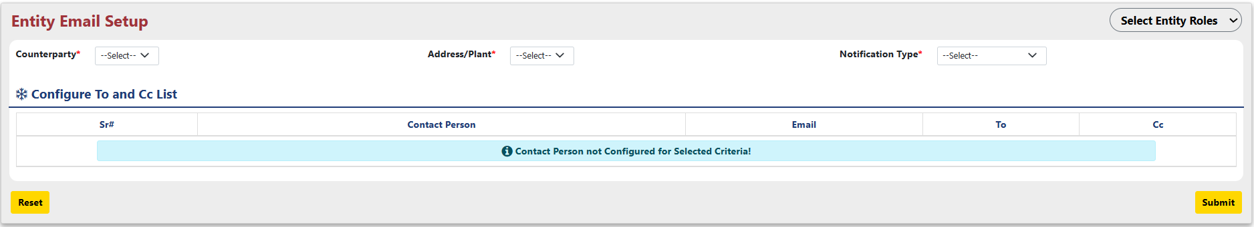

- Selected Entity Role: The dropdown labeled "Entity" likely displays a chosen entity role. This selection determines which counterparties will be displayed in the next section.
- Selected Counterparty: A specific counterparty name is selected from the list. This indicates that the email setup details for this particular counterparty will be displayed.
- Selected Notification Type: This dropdown likely offers various options for the chosen counterparty about emails sent to the configured email addresses.
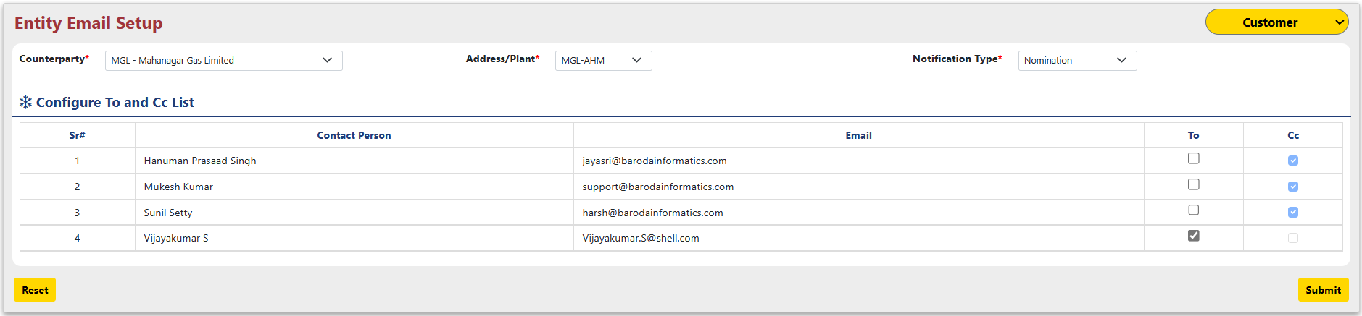

- Configure To and Cc List section allows you to manage the recipient list for emails sent to the chosen counterparty.
- Clicking this Submit button saves the configured email setup for the chosen counterparty.

Counterparty Entity Meter Master

Entity Meter Master menu used to display information related to meters associated with transporter entities.
Entity Meter Master allows transporter entities to manage flow meters used for tracking gas volume transported through pipelines.
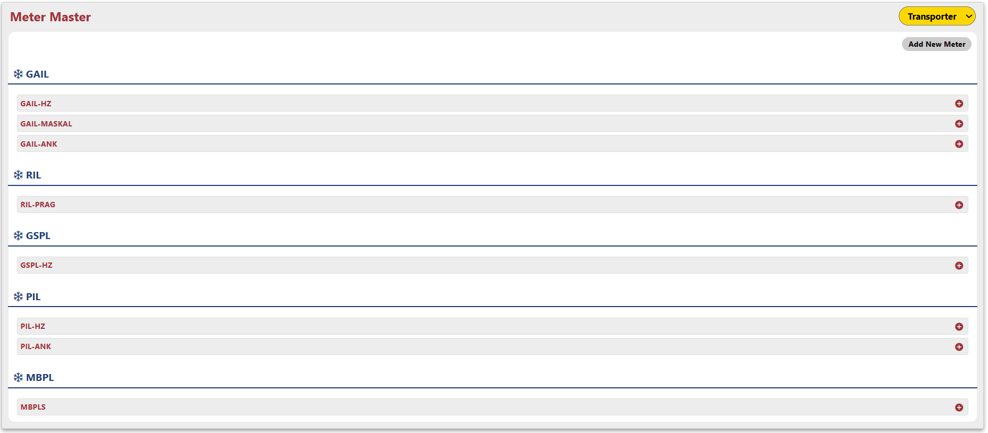
- Clicking the "+" likely expands a section revealing a detailed list of meters associated with the chosen counterparty.

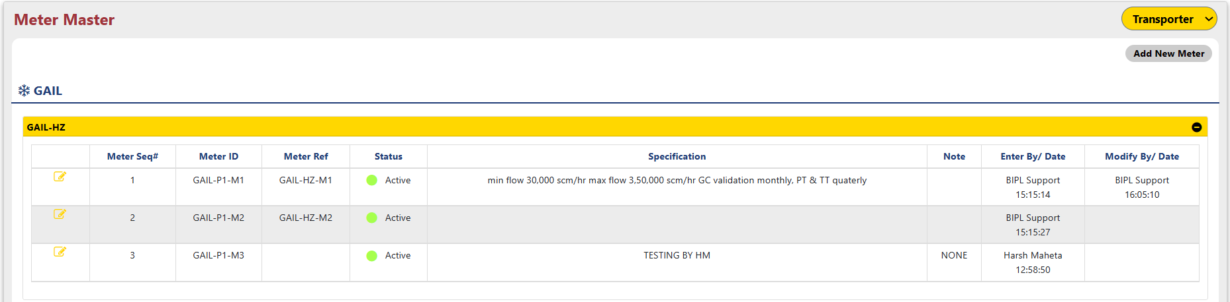

- Clicking the "Add new meter" button initiates the process for transporter entities to register a new meter within the "Entity Meter Master" menu.

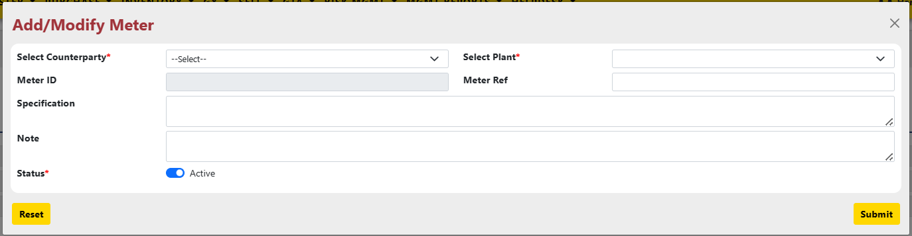

  - Select Counterparty: This dropdown menu likely allows you to choose the counterparty associated with the meter.
  - Select Plant: This dropdown menu used to specify the specific plant or facility where the meter is located.
  - Meter ID: This field auto fill a unique identifier for the meter.
  - Specification: This section might be used to specify the technical details of the meter.
  - Note: This section allows you to enter any additional comments or relevant information about the meter.
  - Status: This indicates the current operational state of the meter.

- Clicking the "Submit" button saves the information entered about the meter within the system. To edit an existing meter, click the pen icon displayed next to “Meter sq#”.
- Clicking "Submit" prompts a confirmation message to verify the addition of the new meter as below.

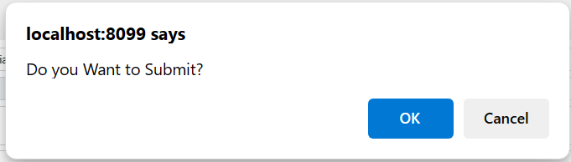

Counterparty Entity Turnover Entry

The "Entity Turnover Entry" form allows users to manage counterparty turnover details. You can select the financial year and choose a pre-defined turnover range for each counterparty listed in the table.
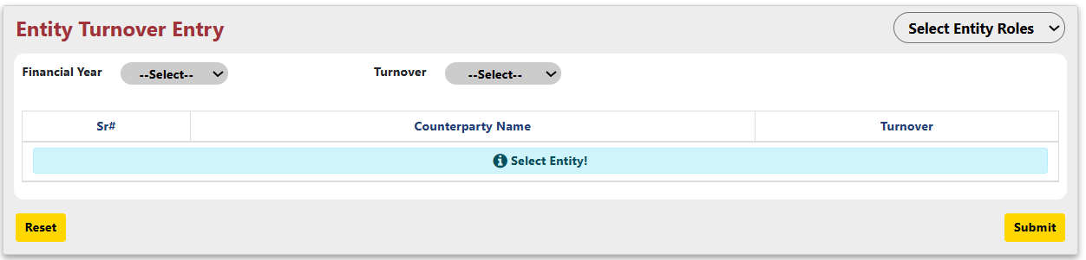
After selecting all the dropdown.

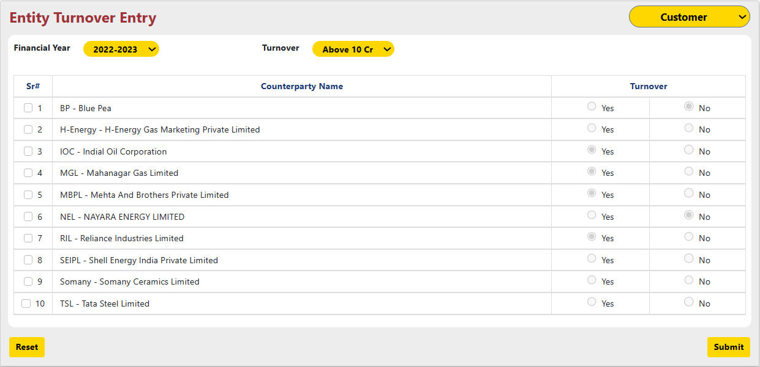

Selecting the checkbox for a counterparty enables you to specify whether their turnover matches the pre-defined range displayed in the "Turnover" column.
Clicking "Submit" saves the information for the chosen year and prompts a confirmation message for verification.

Counterparty Entity Tax Master

The "Entity Tax Master" menu allows users to manage tax information for counterparty.
- Select Counterparty and Business unit: Choose the specific company and potentially their business unit and state after selecting the entity role.
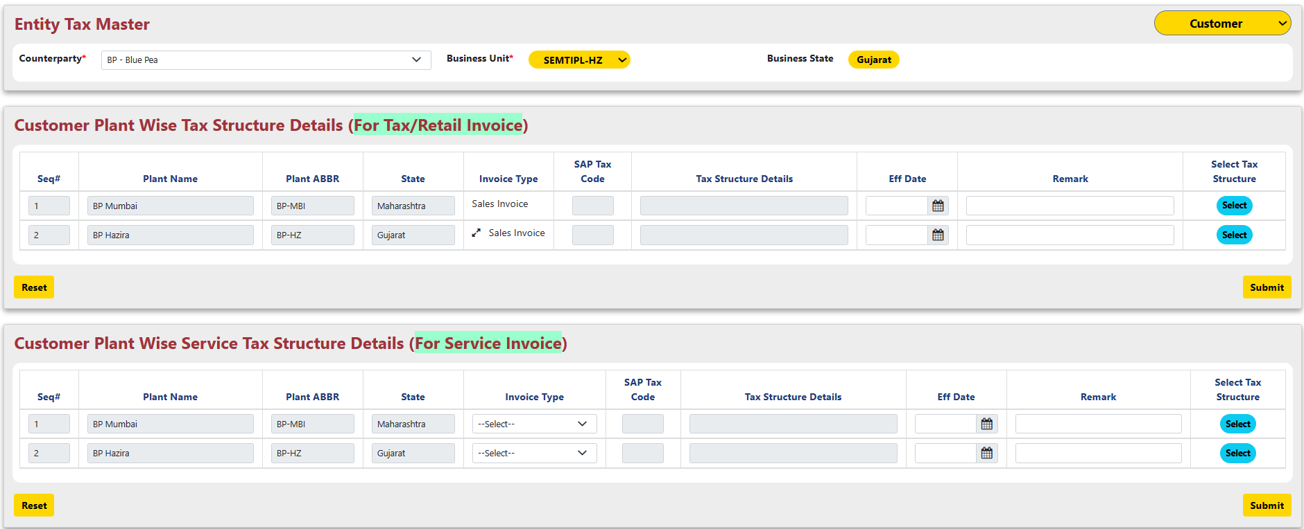

- Clicking the "Select Tax Structure" button opens a separate window where you can browse and choose the desired tax structure to be applied. This selection will likely be reflected in the "Entity Tax Master" menu for the chosen counterparty.

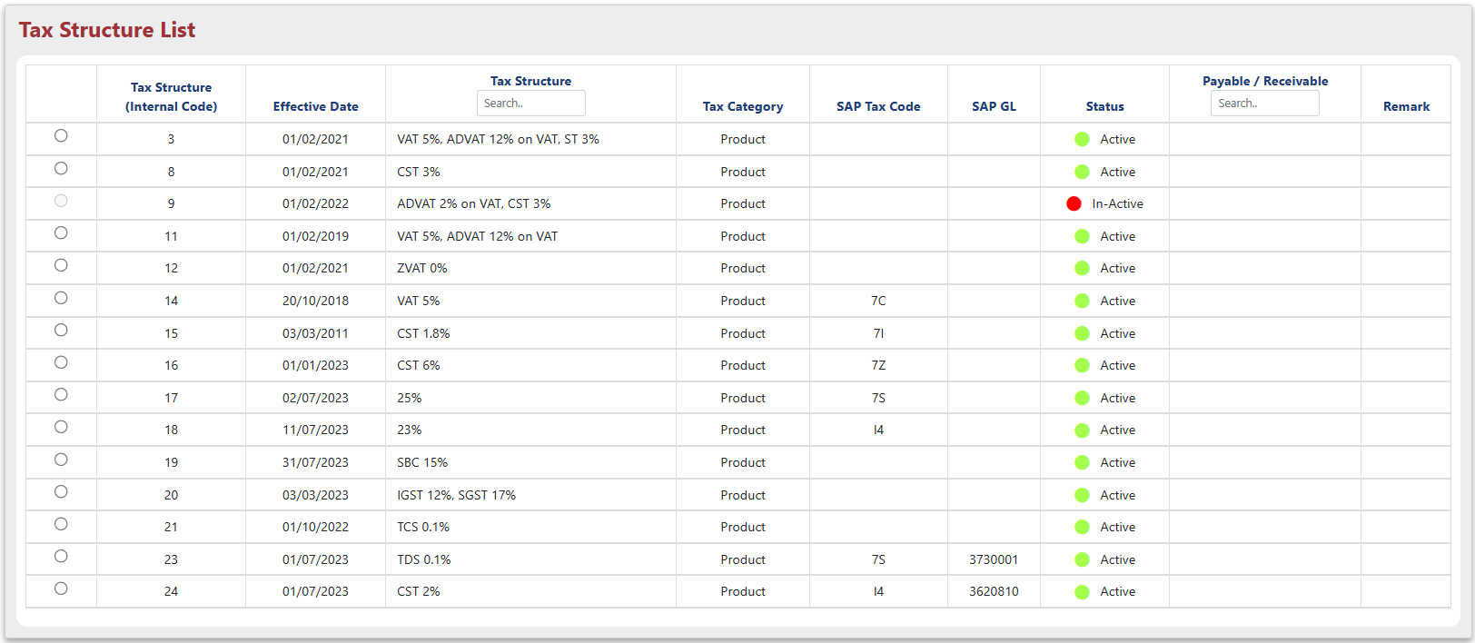

- Enter an Effective Date specifying when this tax structure becomes applicable.
- Add any relevant Remarks or comments about the chosen structure.
- Clicking "Submit" after selecting the tax structure, effective date, and remarks triggers a confirmation message to verify your selection before finalizing the process.

Counterparty Entity TCS/TDS Master

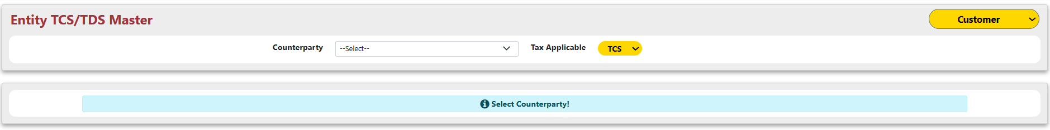
"Entity TCS/TDS Master", helps to manage taxes withheld or collected from counterparties.
- Select the specific Entity role and counterparty you want to manage tax settings for.

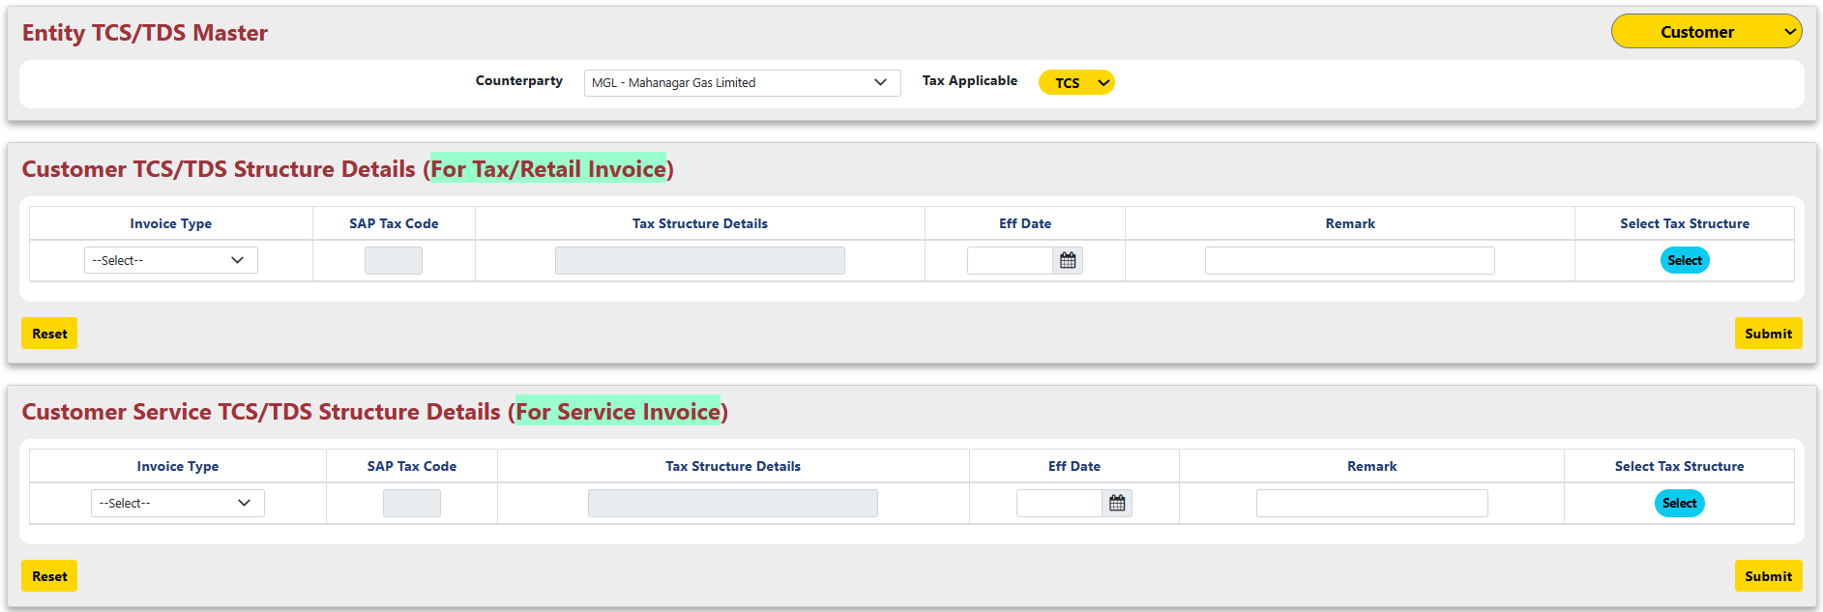

- Clicking the "Select Tax Structure" button opens a separate window where you can browse and choose the desired tax structure to be applied.
- Enter an Effective Date specifying when this tax structure becomes applicable.
- Add any relevant Remarks or comments about the chosen structure.
- Clicking "Submit" after selecting the tax structure, effective date, and remarks triggers a confirmation message to verify your selection before finalizing the process.

Sub Module – Tax

Tax within the system likely serves as a central hub for managing various tax-related functionalities within FMS^{NG}.

Tax Government Statutory Tax Master

Government Statutory Tax Master menu allows users to manage and configure government-mandated taxes within the system. These taxes are likely pre-defined and regulated by the government.

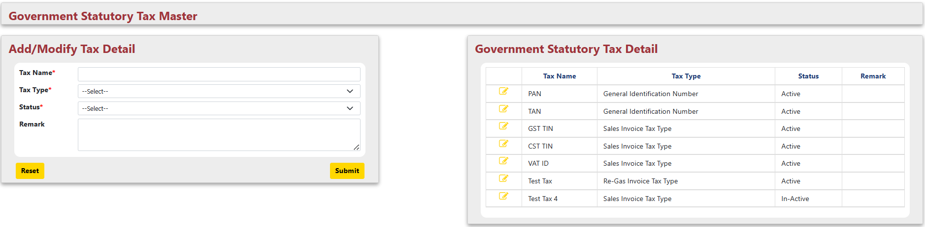

Add/Modify Tax Detail table provides an overview of currently configured statutory taxes, potentially including:
- Tax Name: Name of the specific tax.
- Tax Type: Classification of the tax.
- Status: Indicates whether the tax is currently active or inactive.
- Remarks: Additional information might be displayed.

Clicking the pen icon next to a tax in the "Government Statutory Tax Master" menu allows you to edit its details. Clicking the "Submit" button saves your edits. However, before finalizing, a confirmation message will likely appear to verify modified tax information.

Tax Tax Master

Tax Master Menu likely acts as a central location for managing various tax aspects within FMS^{NG} Application.

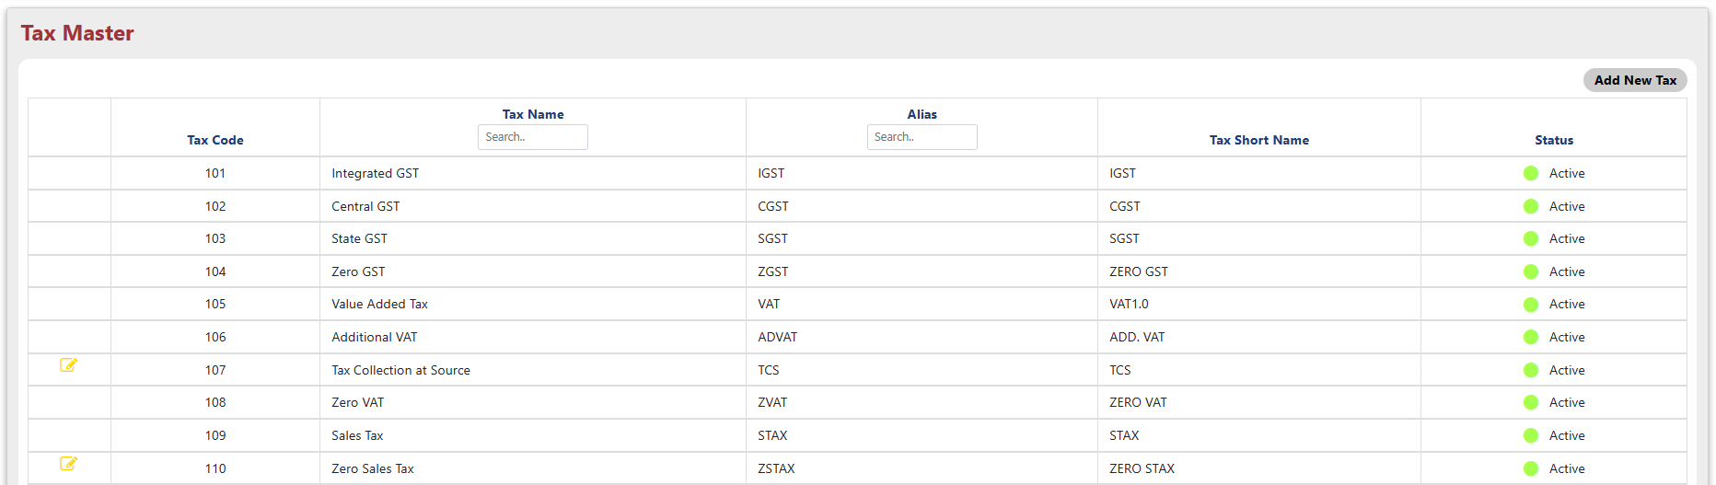

- Add New Tax: Clicking this likely opens a window to add a new tax type and its details.

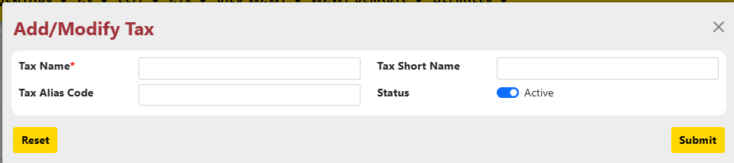

- Edit Tax (Pen Icon): Clicking the pen icon next to a tax allows you to modify its information.
- Clicking "Submit" in "Tax Master" saves tax information (new or modified) and prompts a confirmation alert before finalization.

Note: “Edit locked for Tax Master Code in Use” indicates that you're attempting to modify a tax already used in the "Tax Master" menu, but the system has restricted the edit function.

Tax Tax Structure

Tax Structure menu allows users to define and manage various tax structures applicable within the system. These structures likely determine how taxes are calculated and applied to different scenarios in FMS^{NG} Application.

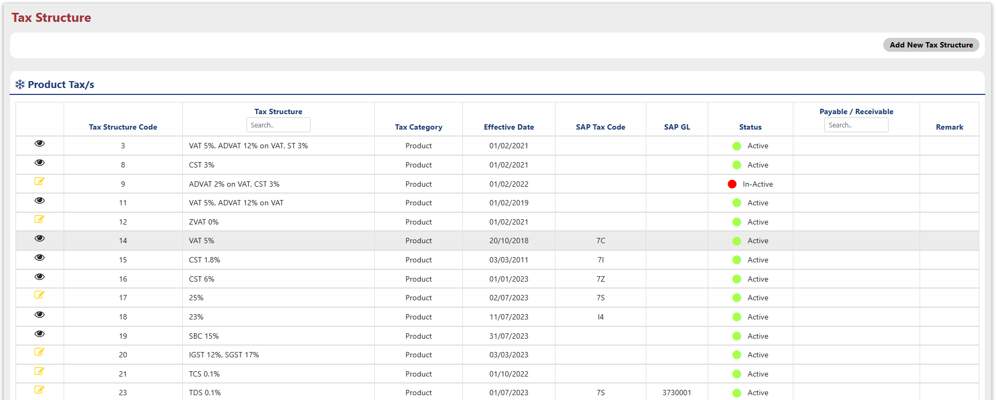

- Add New Tax Structure" button: Clicking this likely opens a window to define a new tax structure with details.
- Pen icon: Clicking the pen icon next to an existing structure allows you to edit its details.

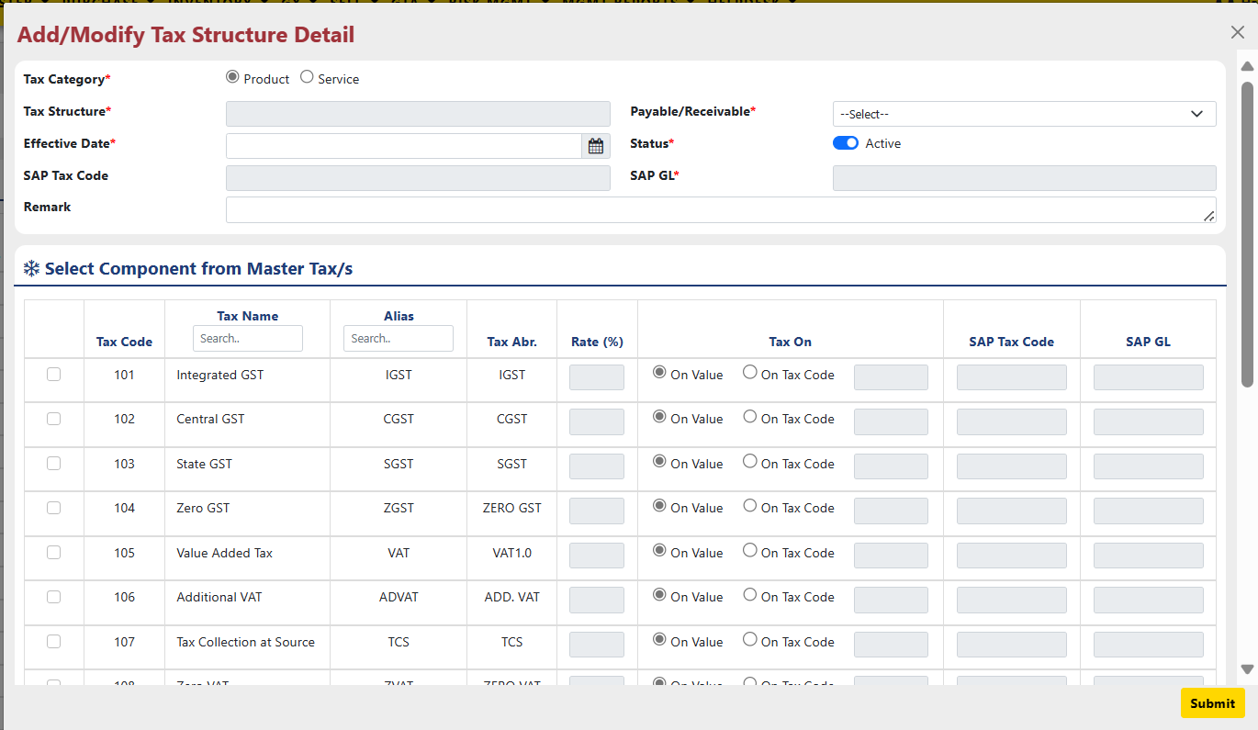

- Tax Category: Defines if the tax applies to products/ services.
- Tax Structure: Tax Structure is auto fill on the bases of component selection.
- Payable/Receivable: Select Tax structure is Payable or Receivable.
- Effective Date: This field specifies the date from which the created tax structure becomes applicable.
- Status: Set Tax structure status active or inactive.
- SAP Tax Code: Auto fill on the bases of component selection values.
- SAP GL: Auto fill on the bases of component selection.
- Remarks: Additional details for Tax Structure.
- Checkbox: Select the checkbox next to each desired tax code you want to include in the structure.
  - Rate (%): Enter the applicable tax rate as a percentage.
  - Tax On: Choose from the dropdown menu how the tax is calculated:
    - On Value: Tax is based on the total value of the product/service.
    - On Tax Code: Tax is calculated based on the value of another tax component within the structure.
- SAP Tax Code: Enter the code linking this component to SAP.
- SAP GL: Enter the General Ledger account associated with this component in SAP.

Clicking "Submit" saves the new tax structure and prompts a confirmation alert before finalization.

Sub Module – Other

"Other" sub module used to handle diverse system configurations through the following menus:
- Interest/Exchange Rate Master & Entry: Manage pre-defined interest rates and exchange rates used in the system.
- Bank Master: Set up and maintain information about the banks the system.
- Energy Sector Master: Configure details relevant to the energy industry
- Holiday Master: Define holidays or non-working days within the system.

Other Interest/Exchange Rate Master

Interest/Exchange Rate Master allows users to manage interest rates and exchange rates applicable within the system. These rates are likely used for various financial calculations.

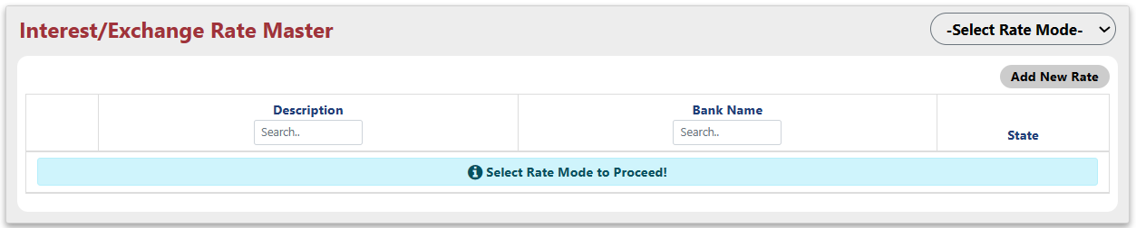

- The "Select Rate Mode" dropdown lets you switch between managing interest rates or exchange rates within the "Interest/Exchange Rate Master" menu.

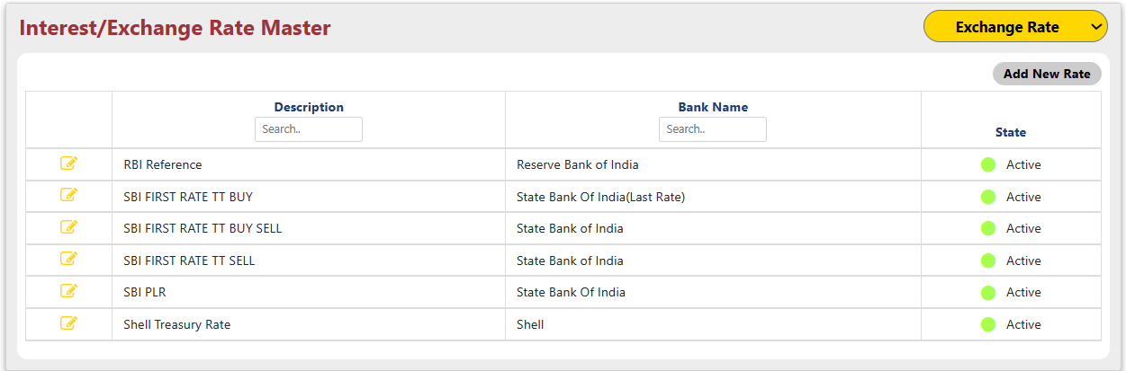

- Clicking "Add New Rate" opens a window to define details like description, bank name, status, and component rates (make sure to select checkbox).

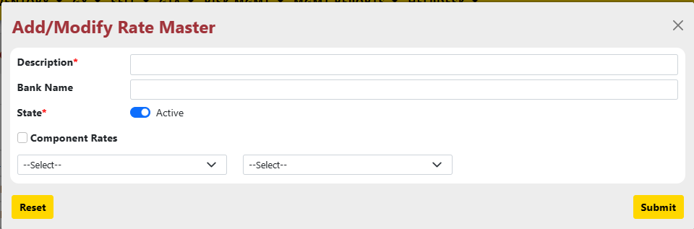

- Clicking the pen icon next to a rate allows editing, followed by "Submit" to save the changes.

Other Interest/Exchange Rate Entry

Interest/Exchange Rate Entry menu allows users to record specific interest rate or exchange rate values applicable on a particular date for a chosen rate type.

- The dropdown menu labeled "Select Rate Mode" allows you to choose between managing interest rates or exchange rates.
- After choosing the rate mode (interest/exchange), you can select the month, year, and the specific rate name to enter a value for that date and type.

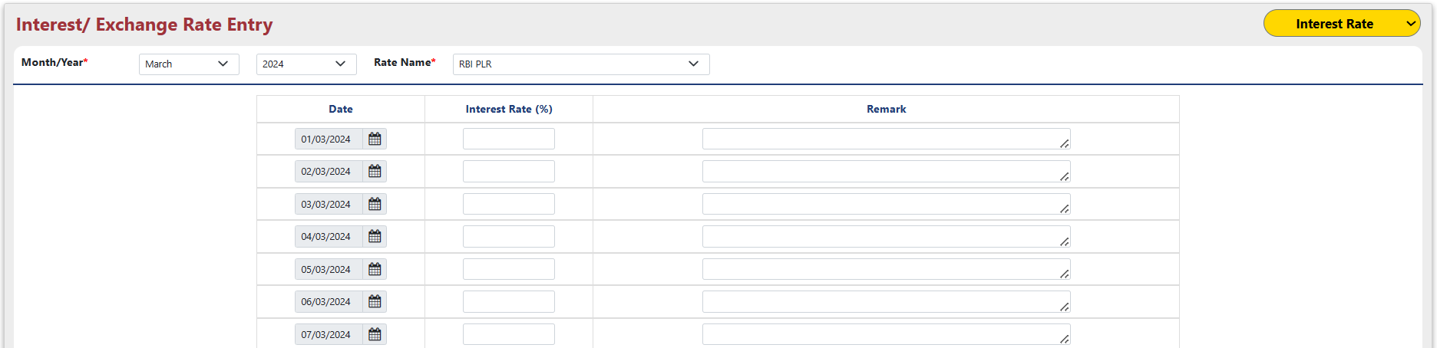
- After selecting the rate type (interest/exchange), date, and rate name, enter the rate value and any remarks, then click "Submit" for confirmation.

Other Bank Master

Bank Master displays a list of banks currently set up in the system, including details like bank names, branch information, and potentially account details.
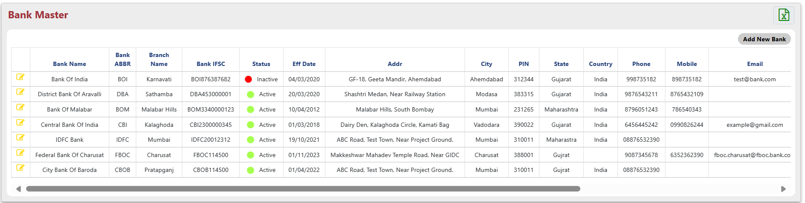
- Exporting Bank Master Details: Clicking this button would initiate the process of exporting the bank information displayed in the table to Excel file.
- The "Add New Bank" button in "Bank Master" opens a dedicated window for creating a new bank entry.
  - Bank Name: Enter the official name of the bank you want to add.
  - Eff Date: Select the date the bank will be operational.
  - Abbreviation: Short form name of the bank.
  - Branch: Specify the branch location.
  - IFSC Code: Enter the bank's IFSC code.
  - Address Details: Provide the physical address of the bank's main branch. City, State, Country and PIN/ZIP Code.
  - Contact Details: Enter Phone, alternate phone, cell and E-mail of Bank you want to add.
  - Remarks: Provide any additional details.
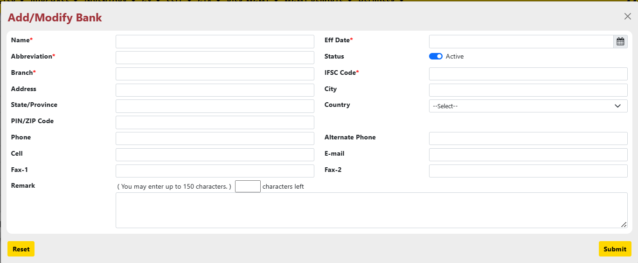

Click "Submit" to save the new bank details. A confirmation message will likely appear to verify the information before finalizing the addition of the new bank entry.

Clicking the pen icon next to a bank name in the "Bank Master" menu likely initiates the process of modifying an existing bank entry.

Other Energy Sector Master

Energy Sector Master menu allows users to manage details and configurations specific to the energy industry within the system.
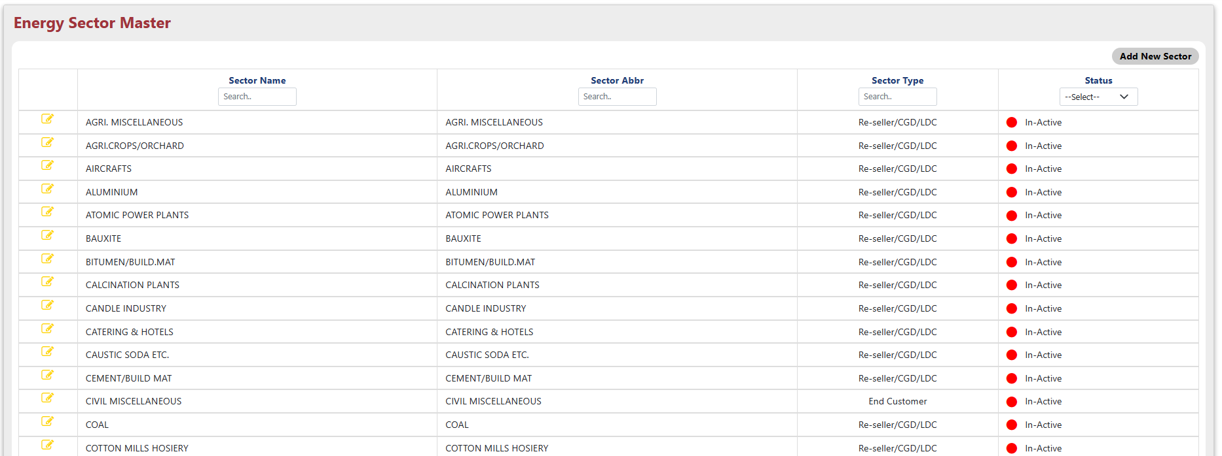

- Clicking "Add New Sector" in "Energy Sector Master" allows defining new sectors with details like name, type, and potentially Status.

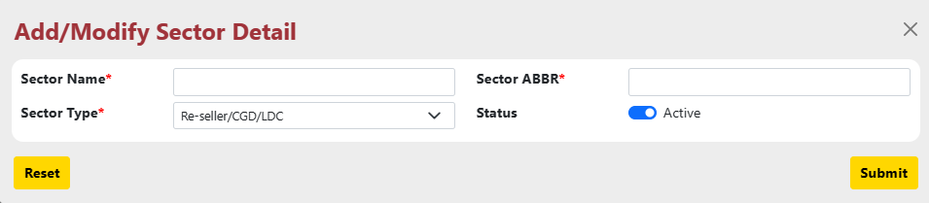

- Clicking the "Pen icon" next to a sector in "Energy Sector Master" allows editing its details.
  - Sector Name: Enter the energy sector name.
  - Sector ABBR: Enter the sector’s short name.
  - Sector type: Select the sector type from the dropdown.
  - Status: Select the status of the sector.
- Clicking "Submit" in "Energy Sector Master" confirms adding a new sector or saves edits to an existing one.

Other Holiday Master

The "Holiday Master" menu functions as a central hub within the system, enabling users to manage all holidays and non-working days effectively. This includes functionalities like adding new holidays, modifying existing ones, and potentially viewing a comprehensive list of all defined holidays within the system.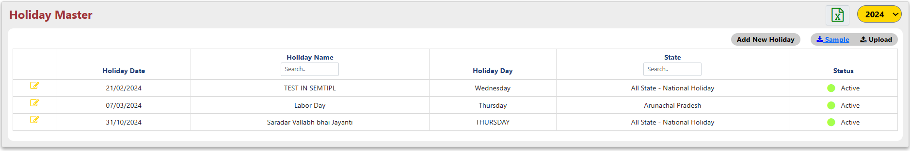

- Exporting Holiday Master Details: Clicking excel button would initiate the process of exporting the holidays information displayed in the table to Excel file.
- Choosing a year from the dropdown in "Holiday Master" filters the displayed holidays to those specific to the selected year.
- Clicking "Add New Holiday" in the "Holiday Master" menu opens a window for defining a new holiday within the system.
  - Holiday Name: Enter the name of holiday.
  - State: Select state in which holiday is.
  - Date: Select the date of holiday.
  - Status: Choose status is active or not.
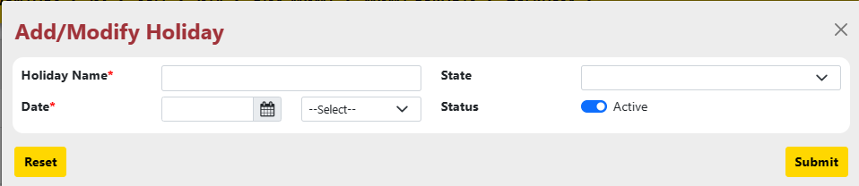
- Clicking "Sample" in "Holiday Master" downloads a sample file as a template to guide the user in formatting their holiday data for uploading into the system
- Click "Upload" in "Holiday Master" to import the holidays from your formatted Excel file into the system.
- Clicking the "Pen" icon next to a holiday in "Holiday Master" allows editing its details.
- Clicking "Submit" in "Holiday Master" confirms your action (adding a new holiday or modifying an existing one) and triggers an alert message for confirmation.

Report Design and Layout

Sub Module – Reports

Reports Counterparty Matrix

The "Counterparty Matrix" menu offers a comprehensive view of all counterparties within the system, including details like:
- Counterparty Name
- Abbreviation (ABBR)
- Entity Role
- Category
- Clearance
- Status
- Requested By
- Approved By
This allows for efficient management and analysis of counterparty information.
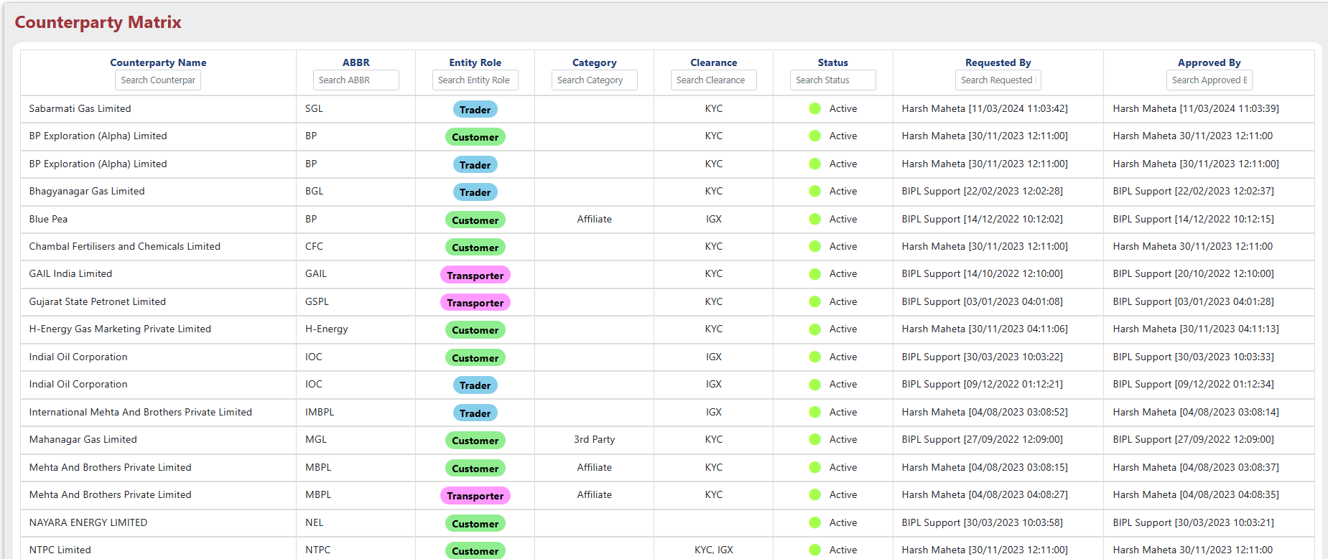

Reports Counterparty Audit Report

The "Counterparty Audit Report" menu allows users to view a detailed history of changes made to any counterparty within a specified date range (from-to), including information name, abbr, clearance etc.
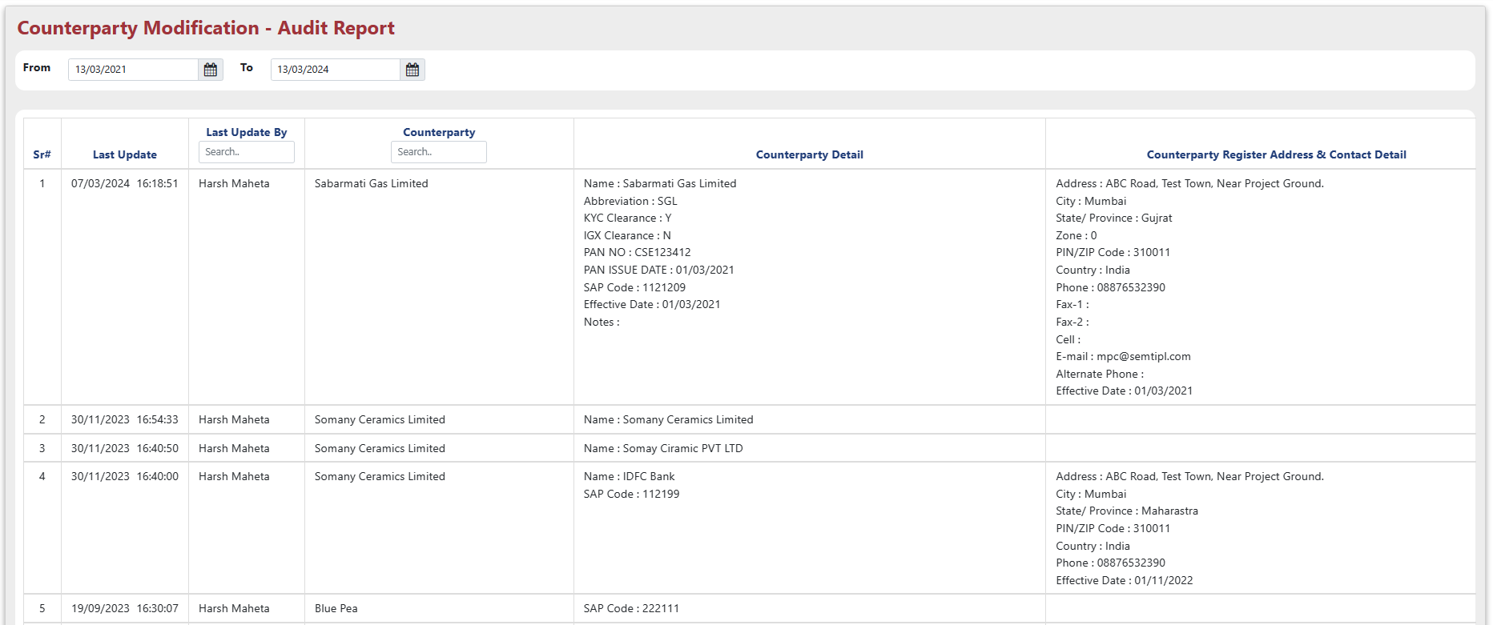

Reports Entity Master Report

The 'Entity Master Report' menu acts as a centralized hub, offering a comprehensive overview of an entity's details such as:
- Encompassing counterparty information
- Registered address & communication details
- Correspondence & communication details
- Billing address & communication details
- Plant(s)/office(s) address & communication details.
Selecting an entity role and counterparty within the "Counterparty Matrix" displays a detailed page showcasing various aspects of the chosen counterparty.
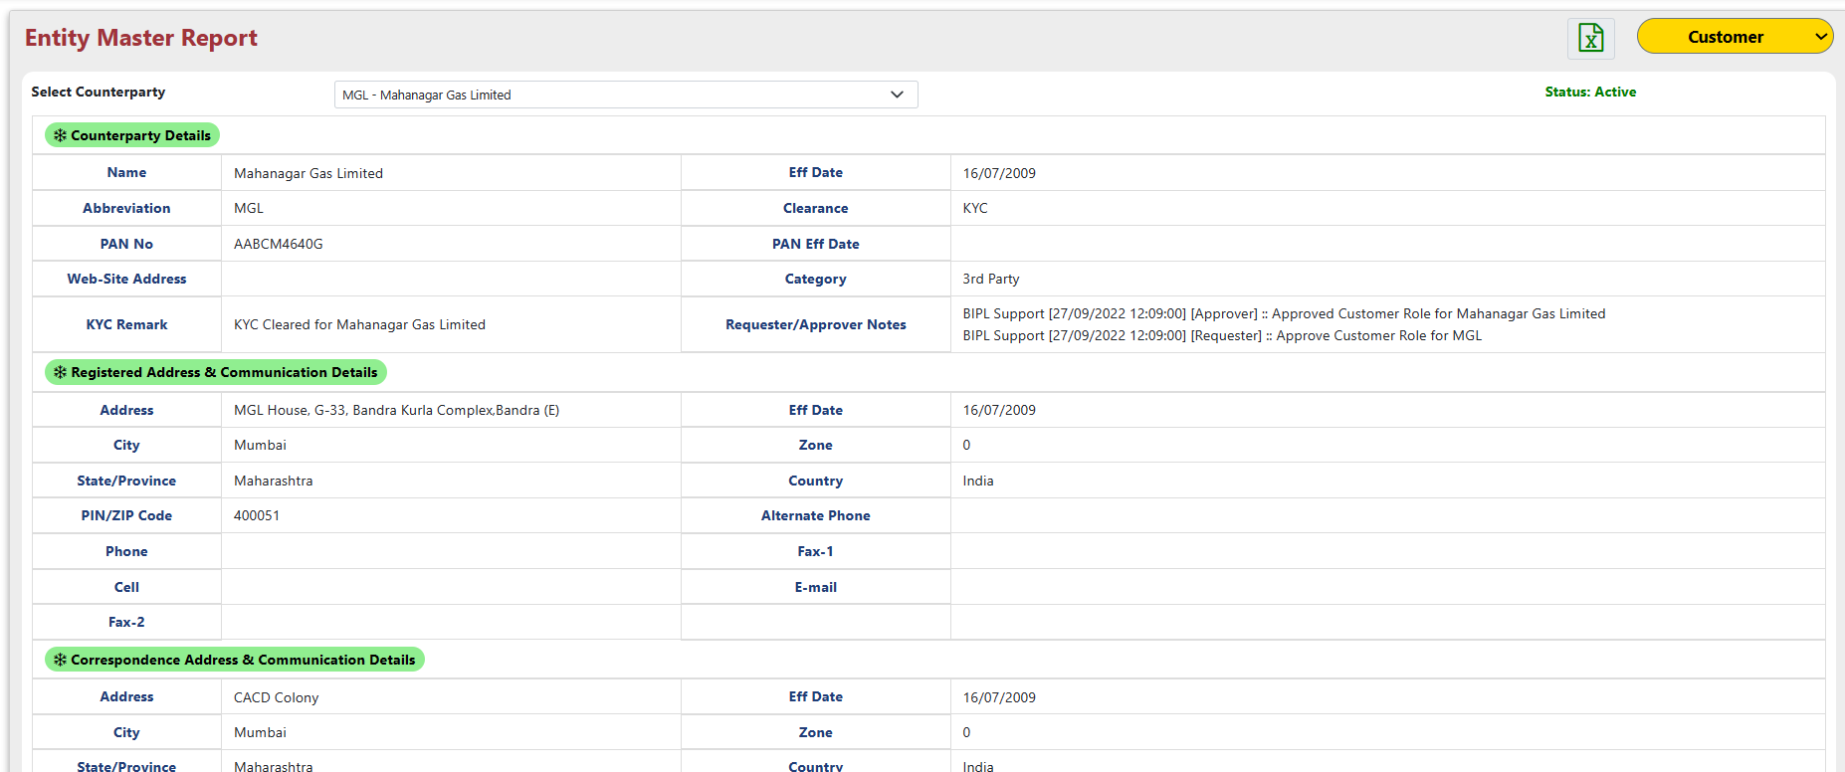

This menu offers an "Export to Excel" function. To export data for multiple counterparties, simply choose the desired entity role without selecting individual counterparties. This ensures you capture all counterparties associated with the chosen entity role in the exported Excel file.

Auditing
The "Audit Trail" within the "Admin" module comprehensively tracks and stores all user actions performed across the various sub-menus of the "Master" module, providing a detailed record of changes made to the system's master data.

